**Ideation Phase**

**Define the Problem Statements**

|  |  |
| --- | --- |
| Date | 8 September 2022 |
| Team ID | PNT2022MID15537 |
| Project Name | Project – ESTIMATION OF CROP YIELD PREDICTION |

**Patient Problem Statement Template:**

Create a problem statement to understand your patient's point of view. The Patient Problem Statement template helps you focus on what matters to create experiences people will love.

A well-articulated Patient problem statement allows you and your team to find the ideal solution for the challenges your Patients face. Throughout the process, you’ll also be able to empathize with your Patients, which helps you better understand how they perceive your product or service.

|  |  |
| --- | --- |
| QUESTION | DESCRIPTION |
| Who does the problem affect? | Farmers, are the persons who needs natural resources such as land, river, nutrients, water and sunlight because they are engaged in agriculture, raising living organisms for food and raw materials. |
| What are the boundaries of the problem? | Consumers, are the persons who needs the food products produced by the farmers because if they don’t get anything from farmer, they won’t able to survive in this world. |
| What is the issue? | Crop production, is the one which should be given to all because it is necessary to eat for surviving and climate, soil quality are also some of the issues. |
| When does the issue occur? | When sowing a seed in improper season it is an important issue. Money, climate is also some of the issues. |
| Why is it important that we fix the problem? | Knowledge about seed sowing is the one which requires proper guidance and quality monitoring in the agriculture field because to get more yield in the respective season |

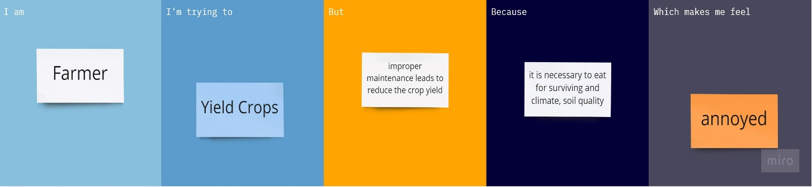

|  |  |  |  |  |  |
| --- | --- | --- | --- | --- | --- |
| **Problem Statement (PS)** | **I am (Customer)** | **I’m trying to** | **But** | **Because** | **Which makes me feel** |
| PS-1 | Farmer | Yield Crops | improper maintenance leads to reduce the crop yield | it is necessary to eat for surviving and climate, soil quality | annoyed |